Write 8 puzzle problem using python code

Aim :To solve the 8-puzzle problem using Python.

Procedure:
- Define the initial and goal states.
- Find the blank tile (0).
- Move the blank tile in possible directions.
- Check if the goal state is reached.
- Display the solution.

Output:
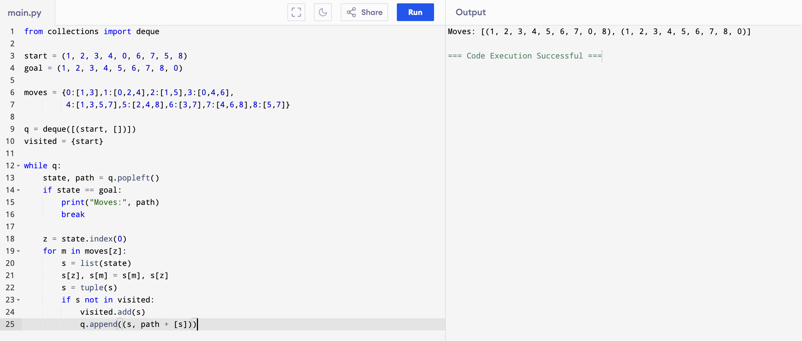

Result: Hence, the 8 puzzle problem has solved

